2021-05-28

FIT5136 2021-S1
Conference Management System
Test Document

Team 48
Xiaohui Ding
Manyan Wen
Mihir Raj Bhanushali
Haorong Ren

Contents
Task 1: Write the test-cases 2
Task 2: Perform white-box testing 3
Login as a Chair 3
Test case 0001: FAILED 4
Test case 0002: FAILED 4
Test case 0003: FAILED 5
Test case 0004: PASSED 5
Test case 0005: PASSED 6
Test case 0006: FAILED 6
Test case 0007: FAILED 7
Test case 0008: FAILED 7
Test case 0009: PASSED 7
Test case 0010: PASSED 8
Test case 0011: PASSED 8
Test case 0012: PASSED 8
Test case 0013: PASSED 9
Test case 0014: PASSED 9
Test case 0015: PASSED 9
Test case 0016: FAILED 9
Test case 0017: PASSED 10
Test case 0018: PASSED 10
Test case 0019: PASSED 11
Test case 0020: FAILED 12
Test case 0021: FAILED 12
Test case 0022: FAILED 12
Test case 0023: FAILED 12
Test case 0024: FAILED 12
Test case 0025: FAILED 12
Test case 0026: FAILED 12
Test case 0027: FAILED 12
Test case 0028: PASSED 13
Result 13

Task 1: Write the test-cases

Task 2: Perform white-box testing

Login as a Chair
Using one of the user credentials in user_db.txt to login as a Chair and use ‘Create conference’ feature.
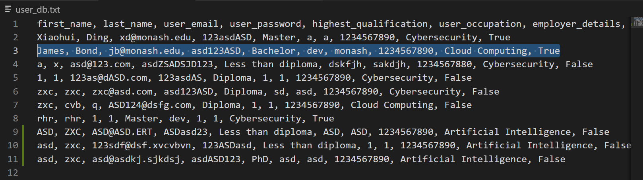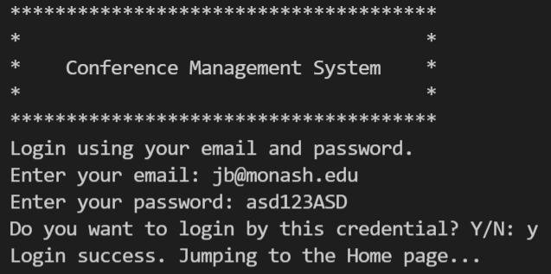
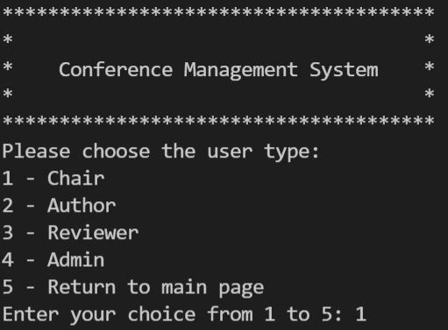
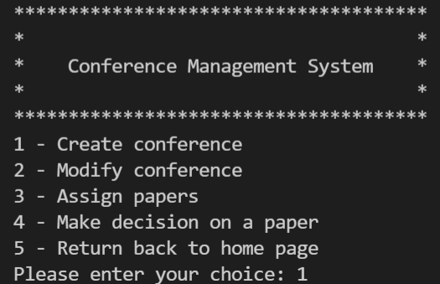

Test case 0001: FAILED
Test if the name can be empty.
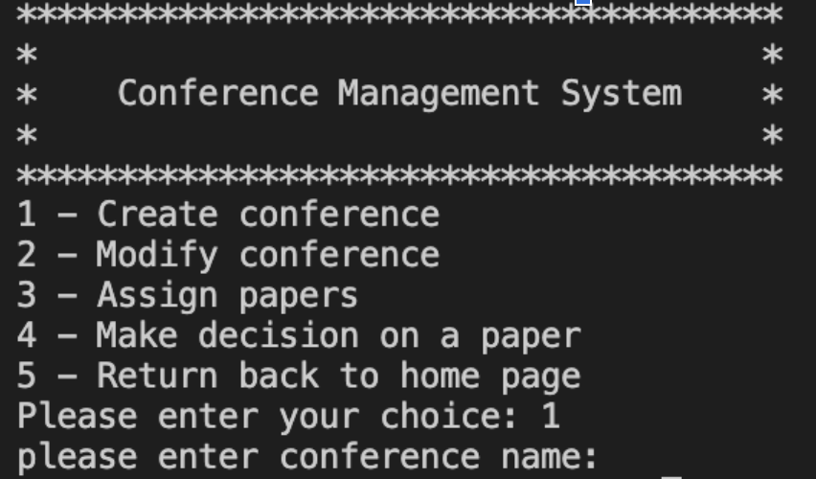
Empty approved and go on enter title.
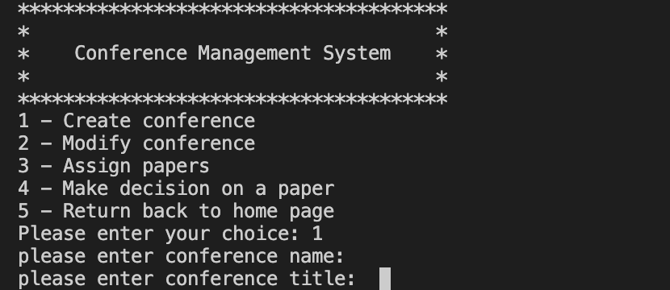

Test case 0002: FAILED
Test if the name can only be number.
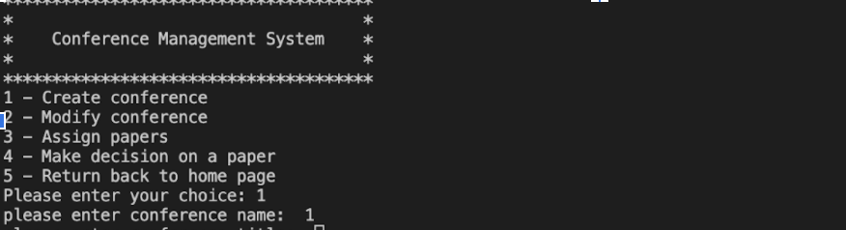
Number approved and went on enter title.
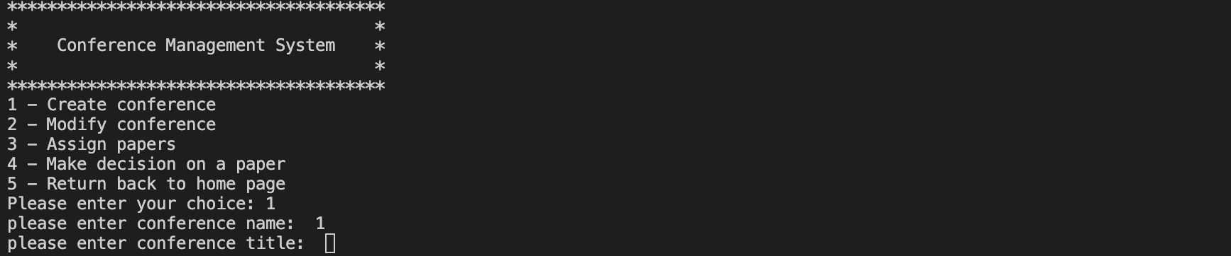

Test case 0003: FAILED
Test if the name can be only special characters.
Special characters approved and go on enter title.

Test case 0004: PASSED
Test if the name can be digits, alphabets and special characters.
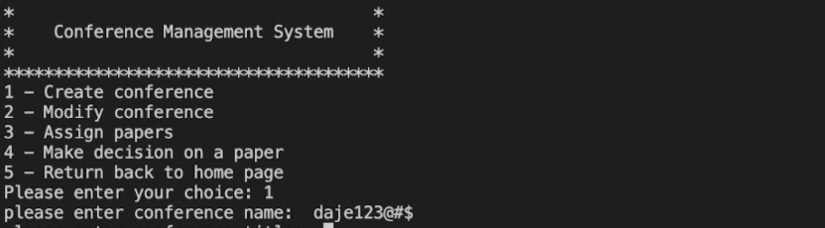
Name approved and went on enter title.

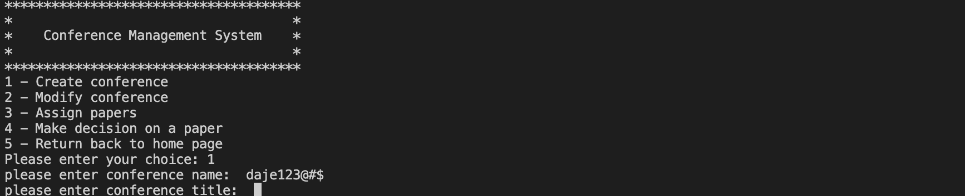

Test case 0005: PASSED
Test if the name can only be alphabets.
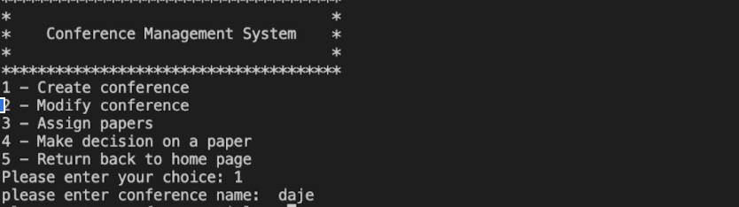
Name approved and went on enter title.
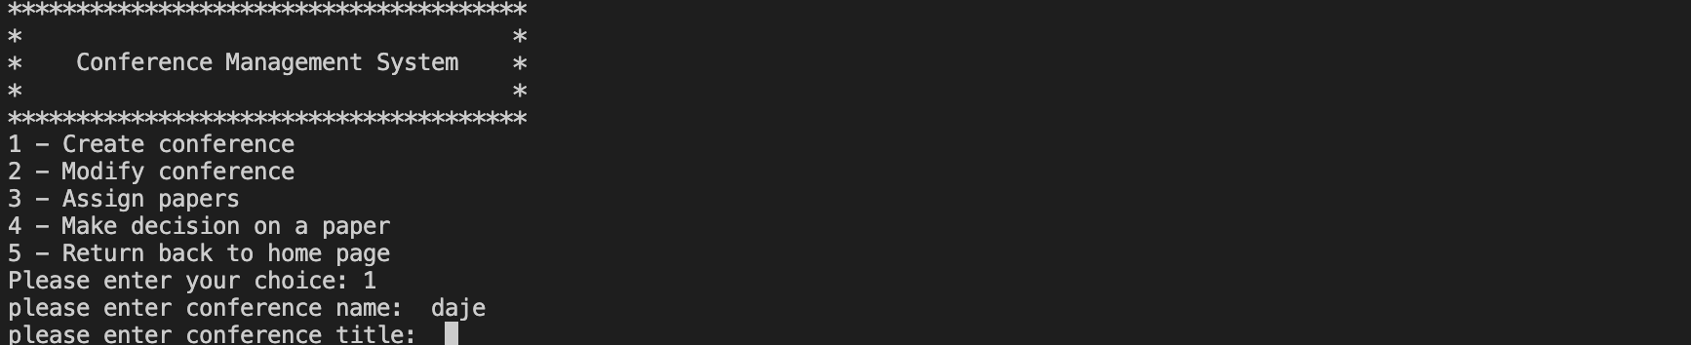

Test case 0006: FAILED
Test if the title can be empty.
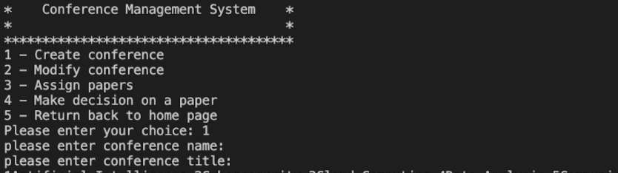
Empty approved and go on enter topic number.
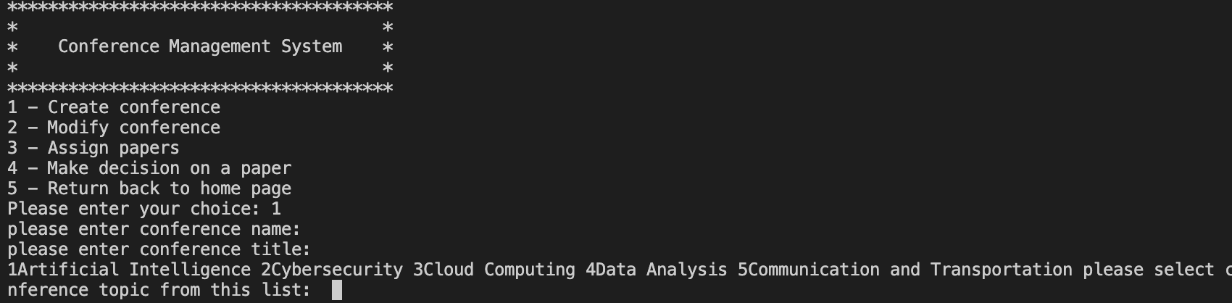

Test case 0007: FAILED
Test if the title can only be number.
Number approved and went on enter topic number.

Test case 0008: FAILED
Test if the title can be only special characters.
Special characters approved and went on enter topic number.

Test case 0009: PASSED
Test if the title can be digits, alphabets and special characters.
Special characters approved and went on enter topic number.
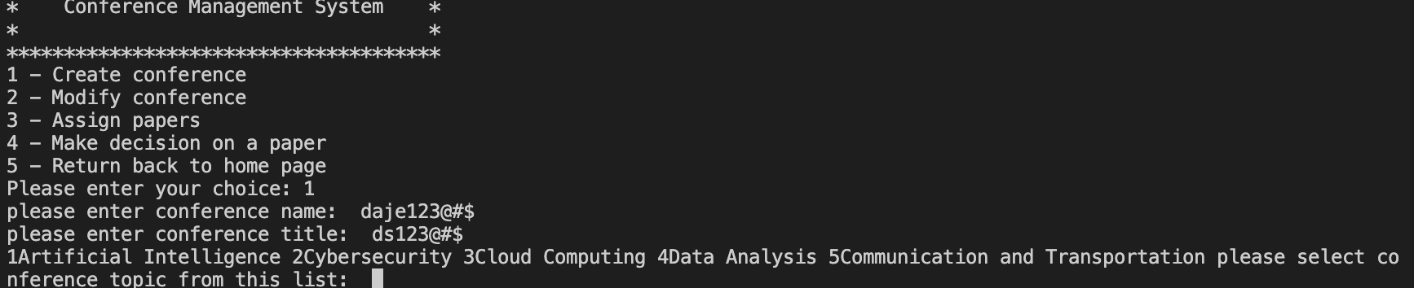

Test case 0010: PASSED
Test if the title can only be alphabets.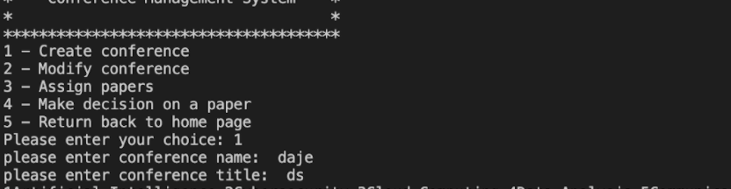
Title approved and go on enter topic number.
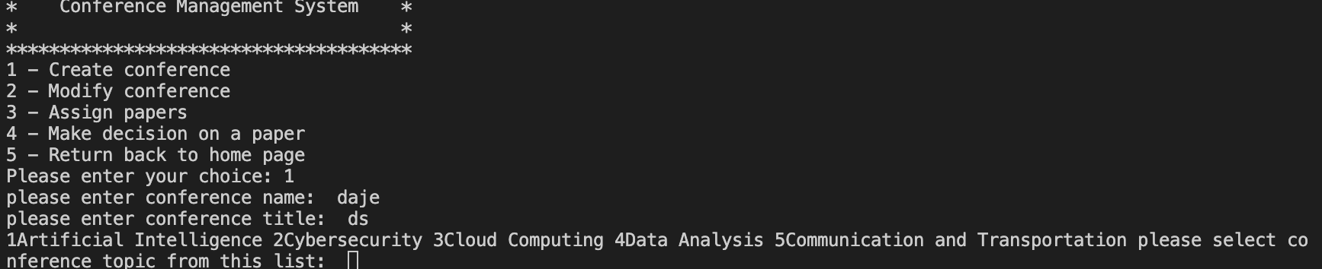

Test case 0011: PASSED
Test if the topic number can be empty.
Please only enter number of choice.
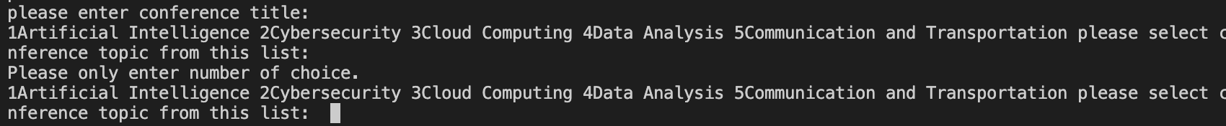

Test case 0012: PASSED
Test if the topic number can be beyond the number of the list.
Please only enter number of choice.
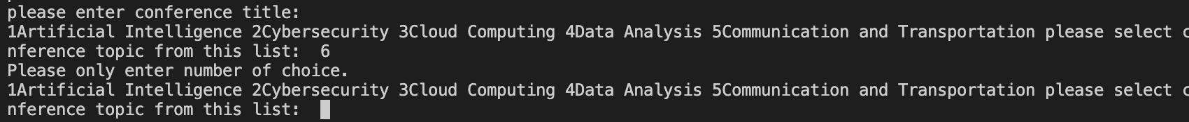

Test case 0013: PASSED
Test if the topic number can be string.
Please only enter number of choice.

Test case 0014: PASSED
Test if the topic number is from 1 to 4.
Topic number approved.

Test case 0015: PASSED
Test if the paper submission due date can be empty.
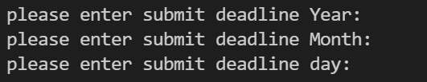
The output is as we expect.
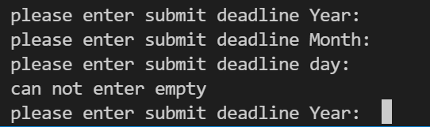

Test case 0016: FAILED
Test if the paper submission due date can be a past date.
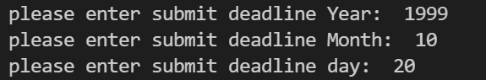
The output is not as we expect.
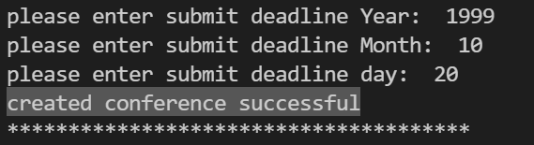

Test case 0017: PASSED
Test if the paper submission due date can include alphabetic characters.
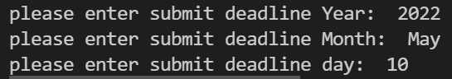
The output is not as we expect.
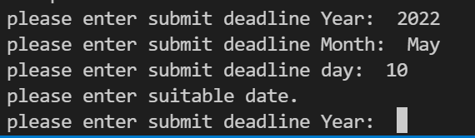

Test case 0018: PASSED
Test if the paper submission due date can include special characters.
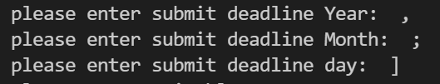
The output is not as we expect.
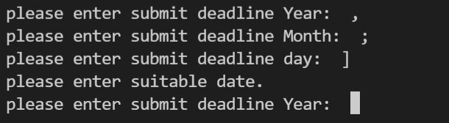

Test case 0019: PASSED
Test if the paper submission due date is of of Australian date format.
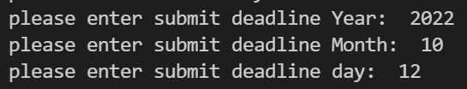
The output is as we expect.
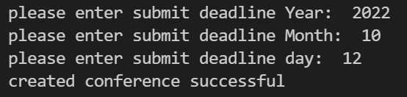
Check with Conference Report:
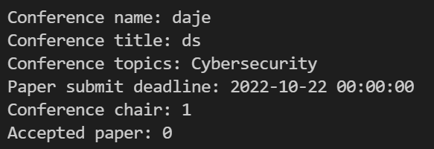

Test case 0020: FAILED
Test if the paper review due date can be empty.

Test case 0021: FAILED
Test if the paper review due date can be a past date.

Test case 0022: FAILED
Test if the paper review due date can include alphabetic characters.

Test case 0023: FAILED
Test if the paper review due date can include special characters.

Test case 0024: FAILED
Test if the paper review due date is of of Australian date format.

We didn’t implement this attribute. As mentioned by Agnes Haryanto in this thread, we should mention this situation in the Test Document and leave this section blank.
But the test of this attribute is similar to the previous one, so we will fix the bugs and implement this attribute later.

Test case 0025: FAILED
Test if the list of papers submitted can be a string.

Test case 0026: FAILED
Test if the list of papers submitted can be a dictionary.

Test case 0027: FAILED
Test if the list of papers submitted can be a list.

Test case 0028: PASSED
Test if the list of papers submitted can have 0 object.

We didn’t implement this attribute in Creating A Conference. But we do have this attribute in our Conference class, and the default of this attribute is empty. So, when the conference is just created and there is no paper submitted to the conference, the Conference Report will be like below:
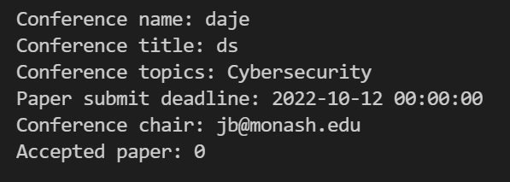
If a few papers have been submitted for the conference, the Conference Report will be like below:
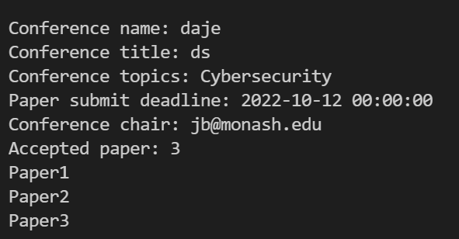

Result
The correct input will create a new conference in our database with 0 paper submitted.

